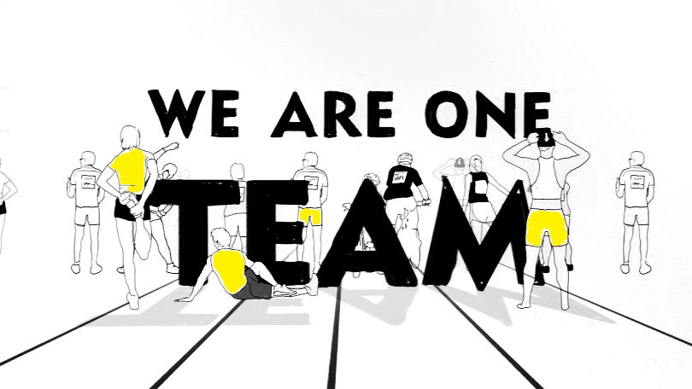

IRON HORSE BICYCLE CLASSIC

**MAY 25-27, 2013** DURANGO, COLORADO

REGISTERATTEAMLIVESTRONG.ORG

**REGISTRATION INCLUDES:**

* Guaranteed race registration
* A personalized fundraising website & tools
* One-on-one support from LIVESTRONG staff
* One of a kind Team LIVE**STRONG** cycling jersey
* Team Happy Hour
* Team Dinner
* Access to team tent in Silverton and Durango Mountain Resort at end of rides with food and beverage

**RESPONSIBILITES ARE:**

* Commitment to raise $400 each of which 50% stays in Four Corners Region
* Represent the mission of LIVESTRONG in training and fundraising
* Inspire and empower those affected by cancer

**ALREADY HAVE AN ENTRY?**

We are also accepting team members who have secured their own race entries. There is no fundraising minimum. At $200 in fundraising you will gain access to weekend activities

Team LIVESTRONG is an unstoppable force of athletes of all levels leading the fight against cancer. 82 percent of each dollar raised goes directly into programs, initiatives and advocacy efforts that support people affected by cancer.

50% of net fundraising proceeds will stay in the Four Corners Region to support people affected by cancer locally.

The LIVESTRONG Foundation provides free cancer support services to help people cope with the financial, emotional and practical challenges that accompany the disease.

JOIN US AT TEAMLIVESTRONG.ORG

